**User Manual:**

1. The application starts when you click on Ravenclaw.php

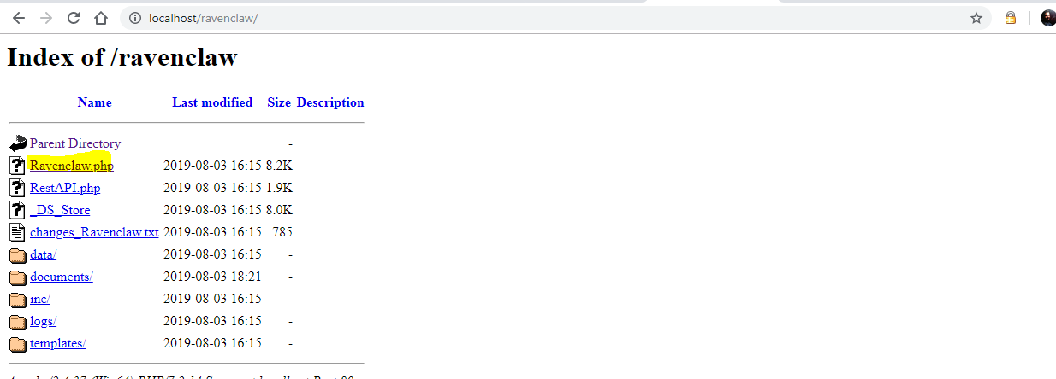

(Fig 1.)

1. The user can login with two types of account:

2.1 User: 2.2 Admin

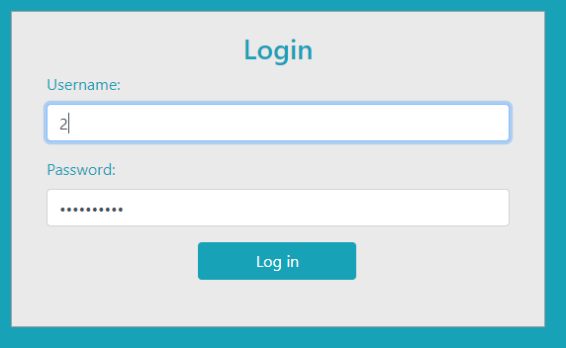 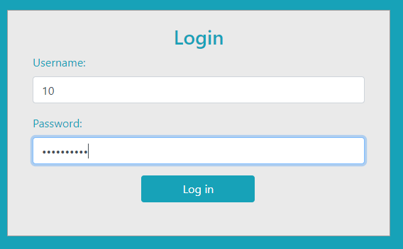

(Fig 2.) (Fig 3.)

The program decides which user has logged in depending on the credentials:

1. Issue book:

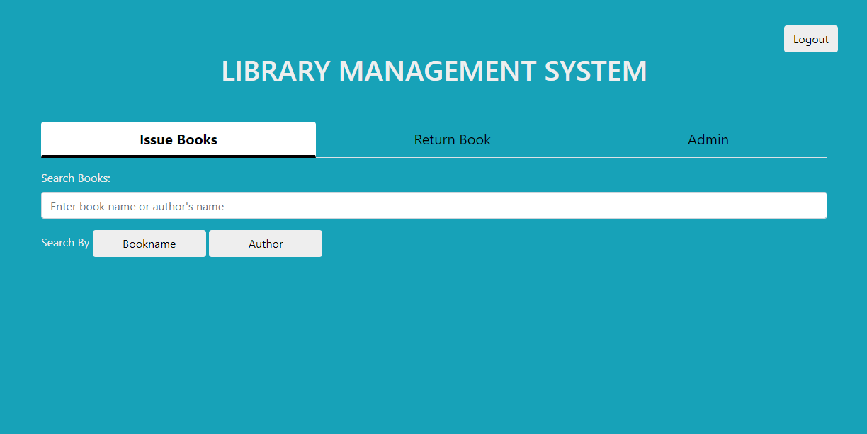

(Fig 4.)

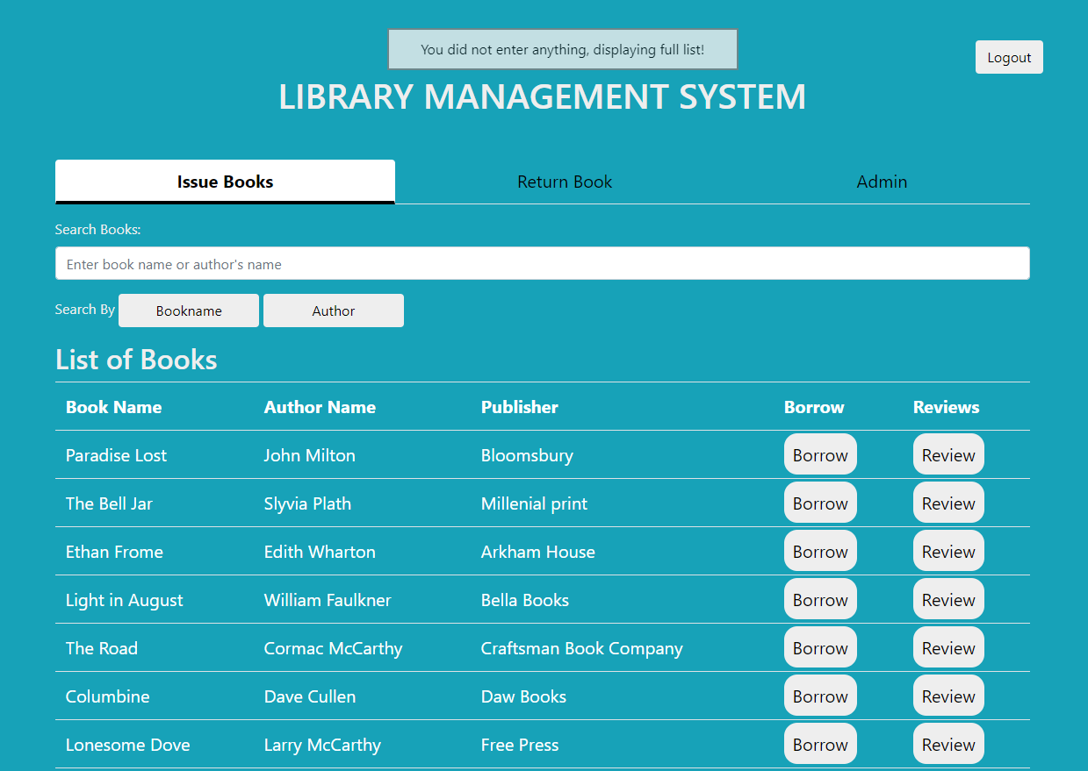

(Fig 5.)

This page is same for user and admin. Here you can search for book by book name or author.

Once you search your book, you can borrow it to get the book.

1. Return book:

Here the user has to enter the ISBN for the book to return it.

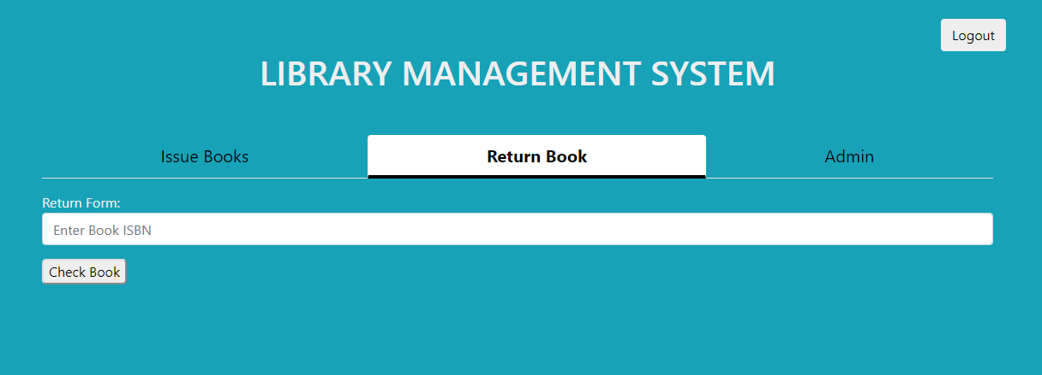

(Fig 6.)

Or he can hit check book to get the list of books that the user issued.

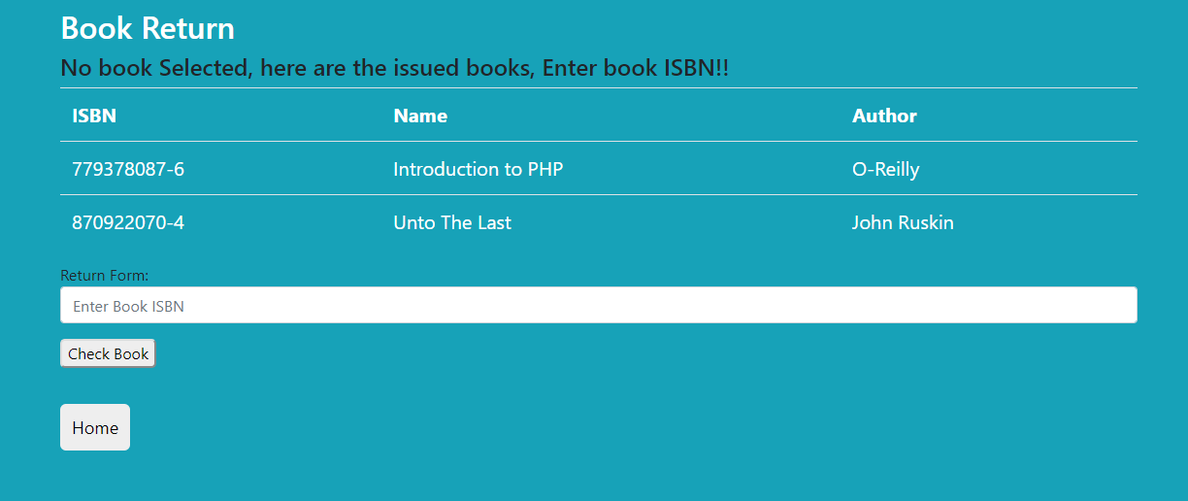

(Fig 7.)

And then check the correct ISBN to return a book.

Once that is done the book details will be shown to verify the book and then confirm book will return the book for the user.

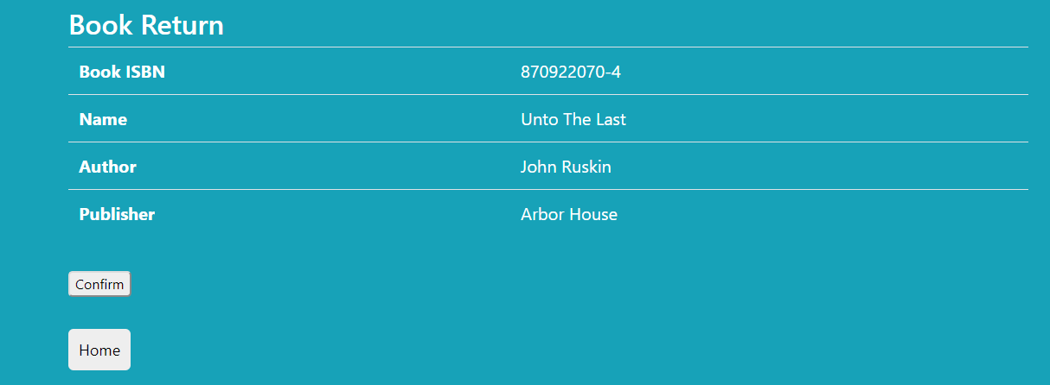

(Fig 8.)

1. Admin tab:

Here you have the options to add/edit books add/edit user.

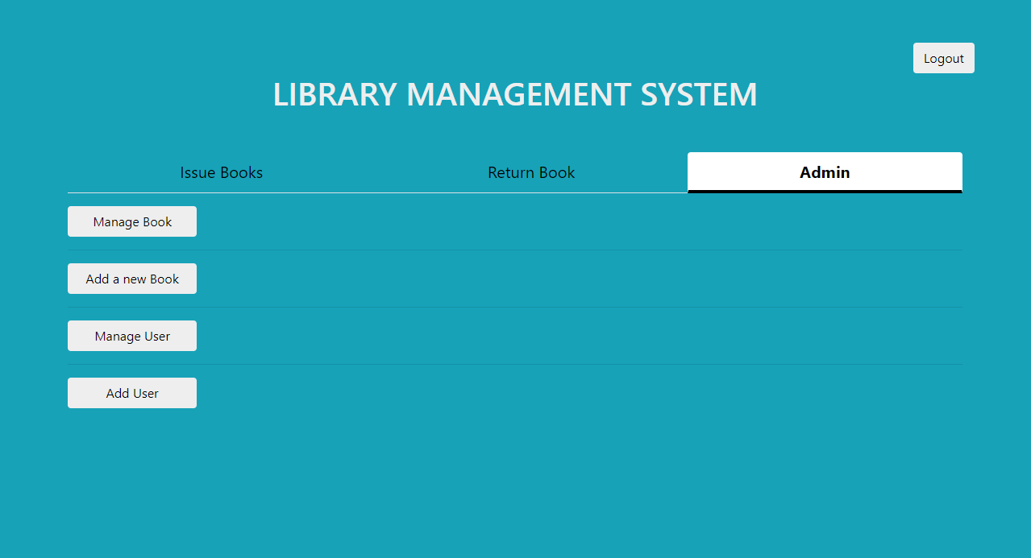

(Fig 9.)

Manage books help you delete the book. If the book is issued you see the following message

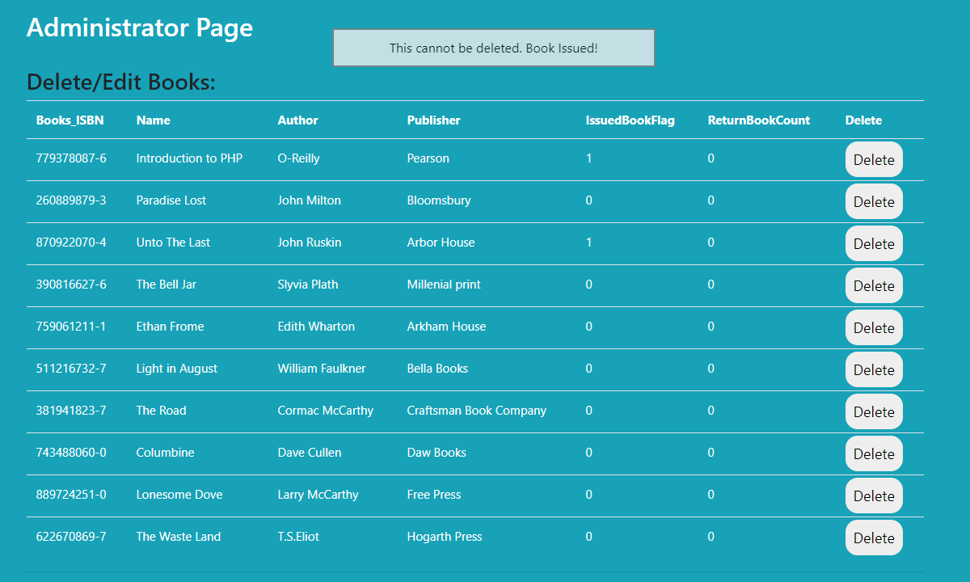

(Fig 10.)

Add a new book using ‘Add book’ button, the following form shows up when you click the Add book button. All the fields are mandatory over here. And error message are shown when the fields are left blank.

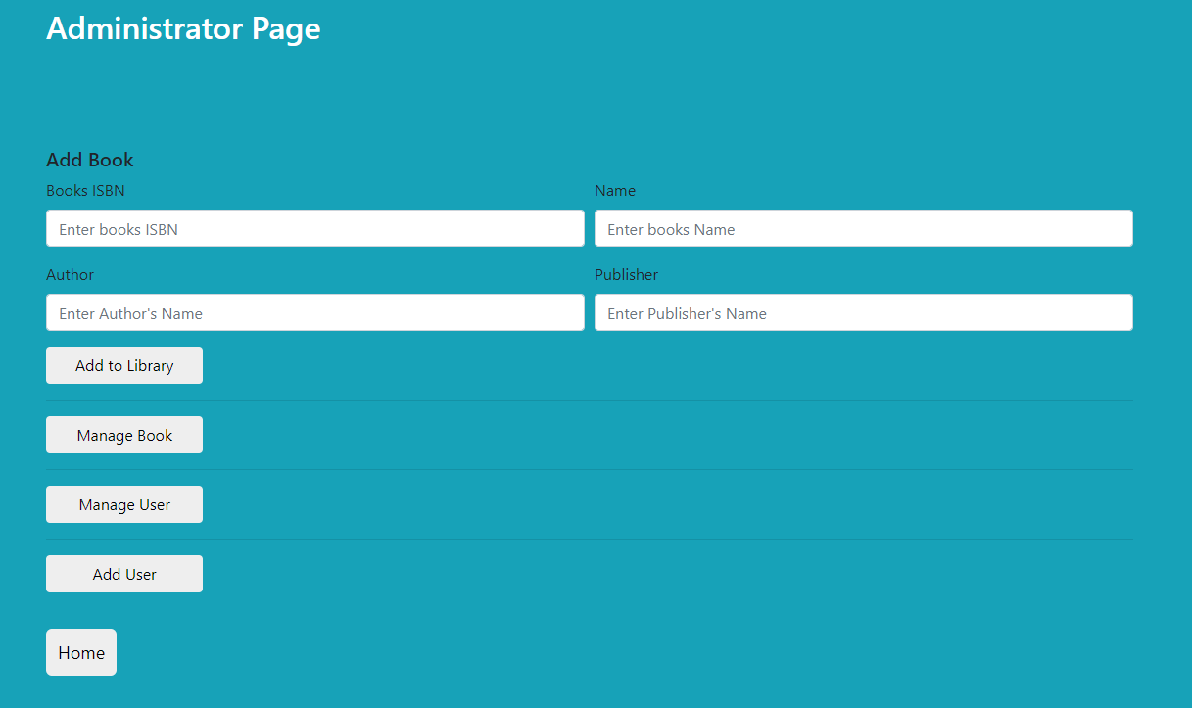

(Fig 11.)

Admin can manage user, and delete or edit then.

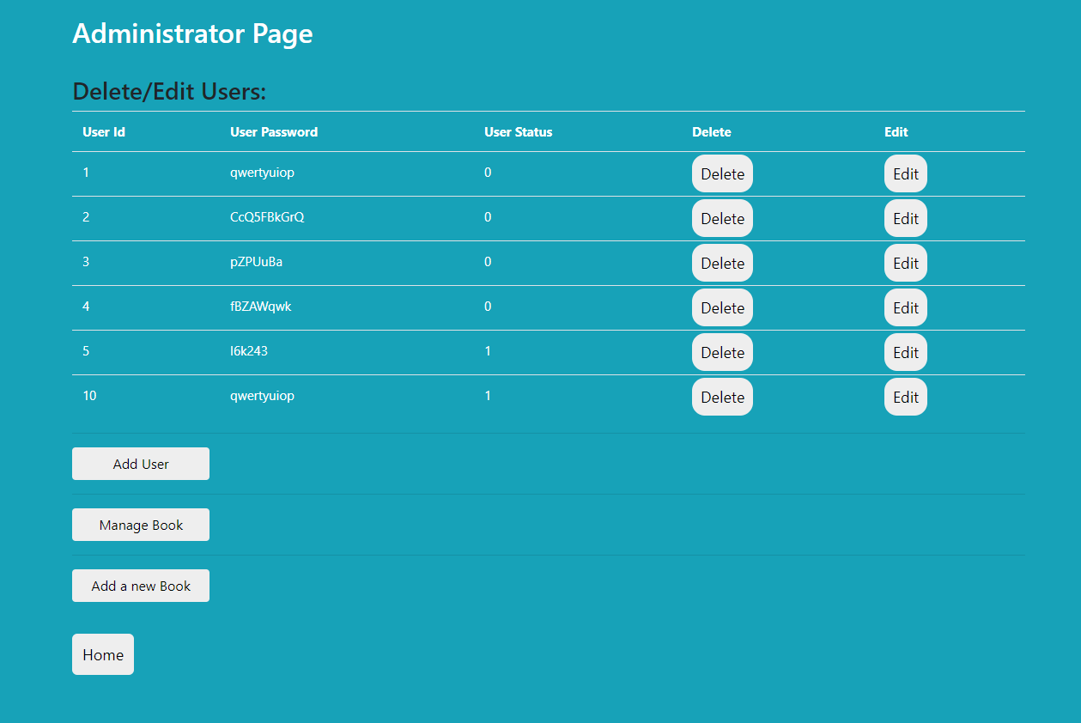

(Fig 12.)

Admin can add a user using add user button.

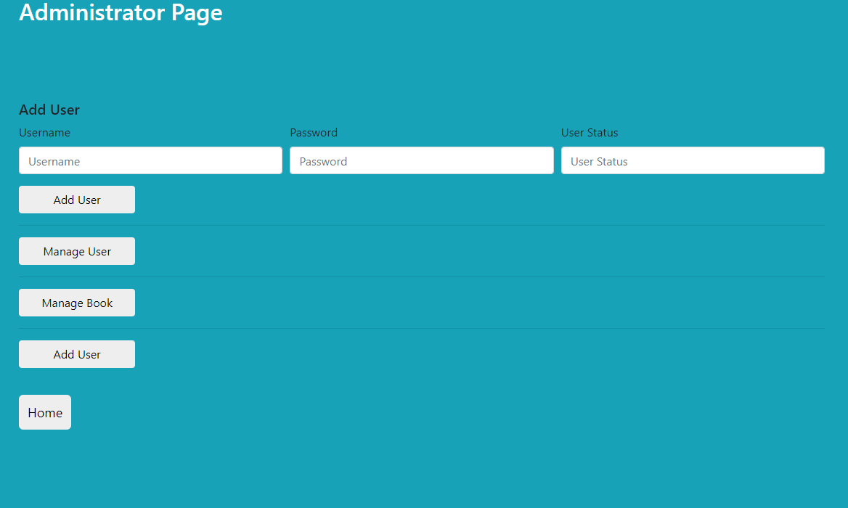

(Fig 13.)